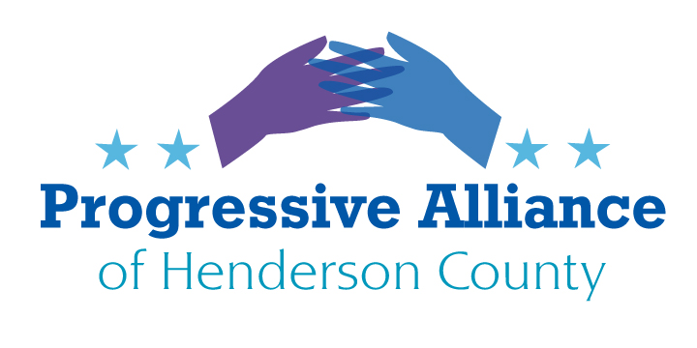

**Virtual Post Card Party # 251 October 21, 2022**

**DACA**

A federal appeals court on Wednesday said the Deferred Action for Childhood Arrivals (DACA) policy violates U.S. immigration law, dealing a blow to an Obama-era program that provides deportation protection and work permits to nearly 600,000 immigrant "Dreamers" who lack legal status. A three-judge panel for the 5th Circuit Court of Appeals concluded the Obama administration did not have the legal authority to create DACA in 2012, affirming a July 2021 ruling from a federal judge in Texas who barred the Biden administration from enrolling new immigrants in the decade-old program.

Despite its conclusion, the appeals court did not order the Biden administration to shut down DACA completely or stop processing renewal applications, deciding instead to leave in place an order from U.S. Judge Andrew Hanen that left the policy intact for current beneficiaries. The government, however, will continue to be prohibited from approving first-time DACA applications.  As of June 30, 594,120 immigrants who were brought to the U.S. as children were enrolled in DACA, half of whom live in California, Texas and Illinois, according to data published by the U.S. Citizenship and Immigration Services (USCIS), the agency that administers the program.

**Write Sen Burr and Tillis referencing H.R. 6 (The American Dream and Promise Act). which recently passed the House.**

**Marijuana**

In his most sweeping use of his clemency powers since taking office, President Biden announced Thursday that he would pardon all Americans convicted of marijuana possession under federal law.  
  
To be clear: No one is currently in federal prison just for marijuana possession, and Biden’s action does not cover people convicted of selling or distributing the drug. However, for the approximately 6,500 Americans convicted of marijuana possession on the federal level, the pardon will still carry sweeping consequences, opening up employment, housing, or educational opportunities that might previously have been closed to them.

**Write POTUS to thank and compliment him for his recent action.**

**(Related story) Blue Ridge Now Oct. 9**

RALEIGH - North Carolina's two top Democratic state officials are urging the Republican-led legislature to decriminalize the possession of small amounts of marijuana in light of President Joe Biden's pardon Oct. 6 of thousands of Americans convicted of "simple possession" under federal law.

Democratic Gov. Roy Cooper and Attorney General Josh Stein, the state's top lawyer who is considering a run for governor in 2024, shared their support for the president's decision at an Oct. 7 task force meeting on racial equity and criminal justice. Established by Cooper in June 2020 after George Floyd's murder, the 24-member panel of law enforcement officers, attorneys, civil rights advocates and state officials had recommended in a 2020 report that state lawmakers replace the misdemeanor charge for possessing up to 1.5 ounces of marijuana with a civil offense on par with a traffic infraction. The General Assembly did not act on this recommendation.

**Contact Gov. Cooper and AG Stein with your plaudits. Also contact State Sen. Edwards and Rep. Moffitt to request their support of initiatives to treat marijuana possession as a citation, instead of a crominal situation.**

**COVID-19**

Dr.Anthony Fauci is retiring at the end of 2022. He has served our country through several infectious crisis with a steady hand. **Please send a Thank You to:**

Anthony Fauci, MD

NIAID Director

5601 Fisher Lane, MSC 9806

Bethesda, MD 20892

**Postal Rate Increases** From Common Dreams, Oct. 12

**Postmaster General Louis DeJoy** is facing backlash over his newly announced plan to hike postcard and stamp prices as part of his proposed 10-year overhaul of mail operations, a strategy that critics warn will further damage the Postal Service.

Late last week, the USPS notified the Postal Regulatory Commission (PRC) of its planned price increases, which are set to take effect in January. Under the new pricing proposal, which must be approved by the PRC, the cost of a stamp would rise 4.2% to 63 cents while the cost of a postcard would jump 9% to 48 cents. The Postal Service cited the need to "offset the rise in inflation" in justifying the price hikes, but *Government Executive*'s Eric Katz pointed out Tuesday that "DeJoy has previously suggested the increases would continue to allow the Postal Service to reach a financial break-even point."

H.R. 8781 is Rep. Gerry Connolly's (D-Va.) recently-introduced Ensuring Accurate Postal Rates Act, a bill that would require a reassessment of the authority DeJoy has used to hike prices significantly. "We must ensure that rate hikes do not return the Postal Service to a service of the privileged," Connolly said during a hearing last month.

**Write Rep. Cawthorn** and ask him to support HR8781 when it is brought to the floor for consideration. While you’re at it, also **write to Sens. Tillis and Burr** and request their commitment to support a similar effort in the Senate.